Devops-skill lab report

SPLUNK-AUTHENTICATION
DATADOG – PACKET MONITORING -CUM SNIFFER TOOL dev environment
it is nothing but a server where we are able to run a s

test environment
where st team perform the functional ,non-functional ,and perform load and performance testing

uat environment
user acceptance test we have to show thee prototype of the customer

production environment
here we c
container is server which acts like a vm and allows program to run on it
docker file is a text document which has a set of instruction to run an application in a container
docker image is a template which has al the requirement to run a software i.e source code, dependencies , platform ,resource
docker hub is registry where we can store all the docker immages
create- docker create ubuntu /bin/bash
/bin/bash defines the root directory of bash in amazon linux it runs the application in the shell mode
docker ps - shows the running containers
docker ps -a show all the containers irrespective of the state
start
docker start <container id/name>
docker exec -it <container_name >/bin/bash this initializes and moves the user into the container
it=interactive terminal
[root@ip-172-31-9-99 ec2-user]# docker run -it --name sample ubuntu /bin/bash
it automates the previous task
deployment of an image ;-
deamon container/detactch mode
every microservice works in a different port no
host port no-user choice this port no defines the port to access info from browser
port no 3002
DOCKERFILE-INSTRUCTION
FROM-INSTRUCTION WILL DEFINE BASE/PARENT IMMAGE OF THE APPLICATION
EVERY DOCKER FILE WILL MUST START WITH FROM INSTRUCTION
BUILD COMMANDS
COPY INSTRUCTION---
TO COPY A FILE OR DIRECTORY FROM A LOCAL MACHINE INSIDE A DOCKER MACHINE
ADD COMMAND :-
ADD FUNCTIONALITY TO SOME THING OR DOWNLOADING PACKAGING FROM INTERNET TO DOCKER IMMAGE
RUN COMMAND-
DOWNLOAD PACKAGES AND INSTALL PACKAGES
.DOCKER IGNORE
REMOVE UNNECESSARY PACKAGE/FILE/DIRECTORY WHILE BUILDING A DOCKER IMMAGE WE WILL USE DOCKER IGNORE

RUN COMMANDS
CMD INSTRUCTION-
IDENTFIES ABOUT THE CODE TO RUN THE CODES
ENTERYPOINT-
IT DEFINES THE ENTERY OF THE INSTRUCTION
Note
cmd will allow runtime argument and entrypoint wont allow runtime arguments
EXPOSE
It defines on which the port the application needs to be accessed
ENV
It defines the environment variables of the application
WORKDIR
It defines the files that are to be kept inside the container
USER
It is used to create user accounts

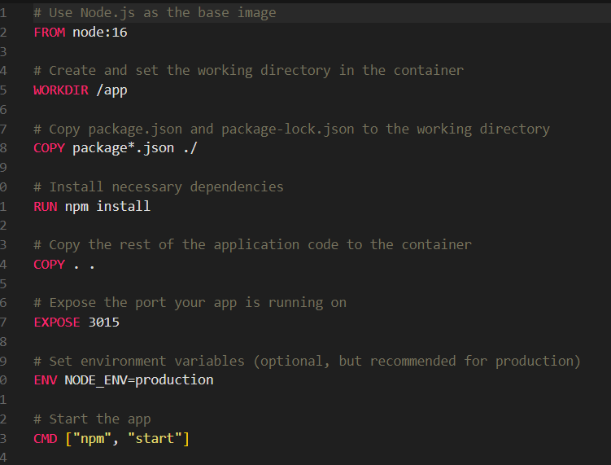
Writing a docker file we need to follow 6 steps
1.identify the base immadge of the application
2.create a workdir
3.copy the dependencies in docker image
4 install the dependencies
5 copy whole source code from local to docker image
6.define the expose port no
7.mention the code to run

Creating a docker image
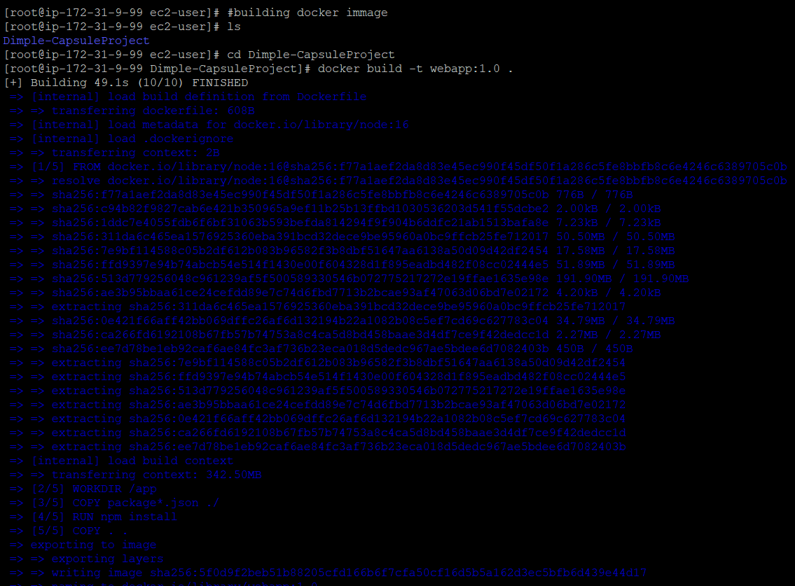
docker build -t my-python-app .
-t my-python-app: Tags the image as my-python-app
. (dot) specifies the current directory as the build context

Running the docker image
docker run -td --name webapp -p 3000:3015 webapp:1.0
-p -tells the port
3000 is the port allocated and and server listens through it
3015 is the port id of the container
DEVELOP A WEBSITE USING CHAT GPT AND WRITE A DOCKER FILE AND DEPLOY IN A NGINX WEB SERVER
IDENTIFY THE PROBLEM WITH THE CONTAINERS
Limitiation
No auto scaling
No self healing
No Load balancing
Orchestration tools
Kubernetes:it is a container management system which allows us top manage microservice tool ,it performs automated deployment of the containers
Featutres
1.orchestration(management cum deployment )
2.Auto scaling
3.Load balancing
4.Self healing
5.platform independent leading it to run it on any cloud, machine
6.we are going to write manifest file (yaml files)

Creating a jump server/bridge host
Note2- we have to install kubctl ,eksctl,awscliYou have to create a user and then set administrative privileges along with that generate access key and codes
There after 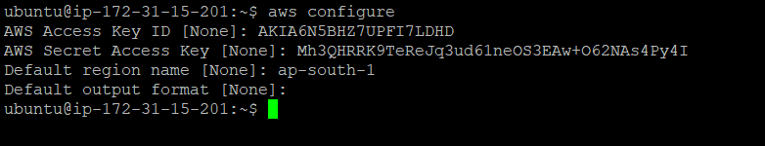
Now check with eksctl to check the installation
Cluster
Kubernetes will manage applications in a cluster
Cluster is a group of nodes which contains master nodes and worker nodes
Node -instance
Master Node-it is a hero of the cluster which takes care to cluster head
It is responsible for the total health of the cluster
Worker node-it is the part where the application is deployed
In a cluster atleast we should have a master node and worker node
There are two type
On-premises cluster:- the cluster is managed by ourself
Off-premises cluster(cloud managed)-it is managed by the cloud providers
And full responsibility of the cloud provider. Aws provides eks (elastic Kubernetes service) to manage the cluster
Master node has 4 parts
1api server
2.et/cd component – a distributed db which stores all the info about cluster and application info inside it in the form of key and value pairs
3.controlers : A controller is responsibe for monitoring health of the application. it always checks the desired state =actual status
4.scheduler : it is a component which schedules a pod in a node
Pod;-it is the place where kubern8s runs the application as containers are sensitive so we run it in pod , they are the smallest deployable unit in Kubernetes
Worker nod components-
1.kubelets:-it is responsible for creating pods and act as an agents ,if something goes wrong in worker machine it communicates it to the master
2.container runtime :- it is tresponsible for pulling the docker image n creating container , starting container and managing the container lifecycle
3.kubeproxy:it is networking component in the worker node ,and responsible for exposing the container on the internet
aws eks update-kubeconfig --name ska-cluster –region ap-south-1
kubectl-is cli command for kubernetess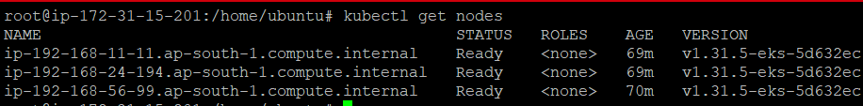
pushing docker in kubernetes
we need to write pod file
1.it has api version
2.kind defines what kind of object being created
3.meta data-labels
4.spec-behaviour of the object
1cpu=1000mi
1gb=1024mb
Namespace-dividing cluster into isolated environments we use a concepts called as namespace
Default namespace-r
Kubectl get namespace
kubectl get all -n kube-system
At the time of cluster creation all the resources metric server core dns all the resources will create a namespace
CREATING OWN NAMESPACE
When we are deploying application production server we will never deploy any application in default namespace
In short multiple ppl working can define their own pods and rules without disturbing other
kubectl create ns ska-ns (creates ns )
kubectl get ns
kubectl get pods
kubectl run test-pod --image nginx
if ds
- every pod has own ipaddress every time a pod goes down the ip changes to overcome we need to create a static url
- if a pod goes down along with a pod we lose data to overcome wwe need to impliment volume in kubernetes
replica set:-
it’s a kubernetes object which is going to maintain the minimum no of nodes 24x7 replica set always maintes desired state=actual state
kubectl apply -f rs.yaml
<replicaset.apps/cart-page-rs created>
kubectl get rs -n ska-ns
shows all rs associated with the designated rs file
kubectl get pods -n ska-ns
shows all the pods associated with the namespace ska

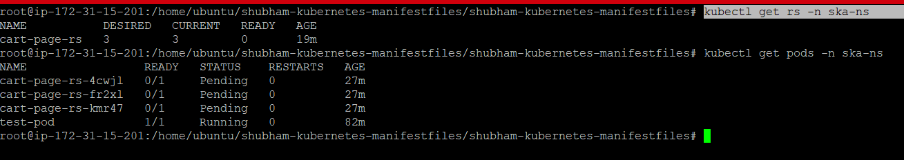
To describe the status of
In real time aplication we don use roll out and roll back operation
Deployments:in kubernetes we are deplying aplication using deployment obl=ject or deployment container
Deployment will manage the replica set and then it will manage the pods
So we need to create a deployment.yaml file
If you want to expose applications through web browser kubernetes will intoduce object called services
1.services:cluster ip service
2.node port service
3.loadbalancer service
Note we are going to impliment how to make a loadbalancer
Monitoring
To understand the status of the application we are implimenting monitoring dashboards we can recognise if something goes wrong in the application and identify how much nodes and pods,cluster health
Monitoring tools like prometheus,grafana are widely used
Prometheus :it is a metric server where it is going tto collect time series of data and sends data to grafana dashboard
Grafana:with the help of grafana we can set up monitoring dashboards where we can visualise data in real time
# snap install helm –classic
Helm is the package manager for kubernetes cluster .

